1. Power up the Quad, you will find:

DSO203 MiNI DSO SYS Version 1.XX

DSO203 MiNI DSO APP Version 2.XX

This is your firmware version

1. Download the firmware version you want to upgrade, from

<http://www.seeedstudio.com/forum/viewtopic.php?f=22&t=1929>

or:

http://garden.seeedstudio.com/index.php?title=DSO_Quad:Upgrading_Firmware#Firmware_List

and, then unzip the source.

For eg: you have download the sys1.37 and then unzip it:

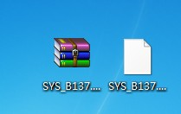

1. Power up the Quad , with pressing the “>||” button

The Quad will be :

Please copy .hex/,bin file to DFU virtual USB disk.

And , a virtual disk will appear:

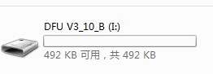

1. When you are upgrading sys or app , Copy the sys_XXX.hex(or app_XXX.hex) to the virtual disk .the disk will auto reset ,and the file name changes to :

C:\Users\Administrator\AppData\Roaming\Tencent\Users\25586548\QQ\WinTemp\RichOle\I)SJC85{OUP~DE[8E7C%D3M.jpg

1. Restart the Quad , the upgrading of app or sys finishes.
2. When you upgrade the FPGA firmware , you need to first copy the .ADR file , after the auto reset, the name changes to :

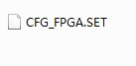

And , then the .bin file, after the auto reset, the name changes to :

C:\Users\Administrator\AppData\Roaming\Tencent\Users\25586548\QQ\WinTemp\RichOle\~359]S1NO~9RV12XUN(AJ{4.jpg

After reset of Quad , the upgrading of FPGA firmware finishes.